
https://www.zavior.org/

Screaming Frog Analysis:
Overall Analysis
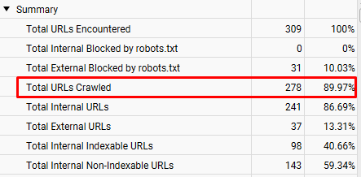
Total URLs Crawled: 278
Images:
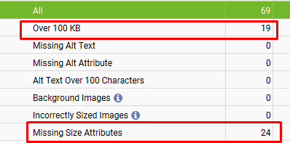
Over 100 KB: 19
Missing Size Attributes: 24

Thank You

